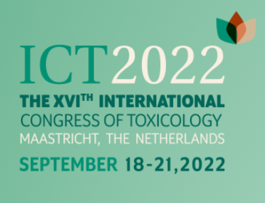
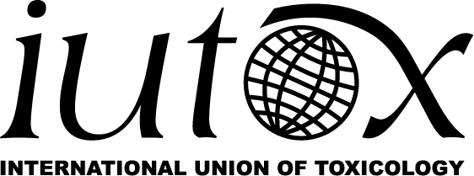

Travel Awards to Attend the
2022 16th International Congress of Toxicology (ICTXVI) in Maastricht, The Netherlands

The International Union of Toxicology (IUTOX) announces the availability of $1,000 travel fellowship awards to attend the 16th International Congress of Toxicology. The meeting will be held in Maastricht, The Netherlands, September 18-21, 2022.
Applicants may be either junior or senior scientists from a country where toxicology is underrepresented. Senior toxicologists need to show more than ten years of experience either working on an active research program or actively practicing as a toxicologist, and junior scientists will need to show less than ten years of experience either working on an active research program or actively practicing as a toxicologist. The following criteria will be used to select award recipients:

• A brief statement indicating how the awardee will benefit from the fellowship;
• Curriculum vitae including e-mail address and phone number;
• A strong letter of recommendation from the applicant’s home toxicology society, however, If the applicant does not have a national toxicology society, a strong letter of recommendation from his/her department or institution may be substituted;
• Written statement demonstrating your ability to meet other expenses to attend the meeting;
• Copy of abstract submitted for ICTXVI for review. (Abstract submission date is March 31, 2022).
Candidates must submit their completed travel award application to IUTOX HQ no later than March 31, 2022. Previous award recipients of 2017, 2018, 2019, 2020, or 2021 ICT, CTDC, or other IUTOX Fellowships are NOT eligible to apply. Awardees will be notified by May 13, 2022 and awards will be issued at the ICTXVI meeting in Maastricht, The Netherlands.

Award information is available on the IUTOX website:
www.iutox.org

IUTOX ICTXVI Travel Award
2022 Application

First Name: M.I.: Last Name:
Organization:
Department:
Address 1:
Address 2:
City: State: Zip Code:
Country:
Phone: Fax:
Email:

Is the candidate a Junior Scientist? Yes No
(Less than ten years of experience working on an active research program or active in the practice of toxicology)
Is the candidate a Senior Scientist? Yes No
(Ten or more years of experience working on an active research program or active in the practice of toxicology)
Year PhD Received:
Is Toxicology underrepresented in the candidate’s country? Yes No
Which Country?
Does the candidate have an active research program? Yes No
Is the candidate currently active in the practice of Toxicology? Yes No
Has the candidate submitted: (attach files to submission email)
1. A brief statement indicating how awardee will benefit from the fellowship? Yes No
2. Curriculum Vitae including an email address/phone number/fax (if available)? Yes No
3. A strong letter of recommendation from the home society or institution? Yes No
4. Statement certifying ability to meet other expenses to attend the meeting? Yes No
5. Is meeting abstract attached? Yes No

